# ACCEPTANCE TESTING

(Utilization of testing tools)

|  |  |
| --- | --- |
| Date | 18th November 2022 |
| Team ID | PNT2022TMID04782 |
| Project Name | Real Time River Water Quality Monitoring and Control System |
| Maximum Marks | 4 Mark |

User Acceptance Testing

User acceptance testing (UAT) is necessary when implementing changes to an IT landscape due to the ever-increasing complexity of software which can cause bugs to slip through even under the most perfect development conditions. Commonly, acceptance testing is performed as the last step before the release of a software, after all other testing phases have exited. As implied by its name, user acceptance testing is typically performed by the end users in a real setting during the unit-, integration- and system testing phases.

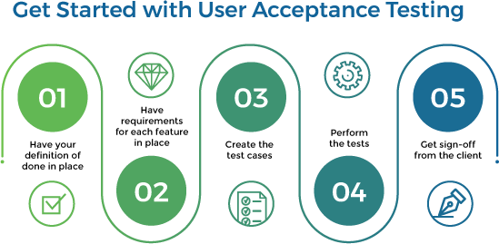

# Test planning, monitoring and control

This step entails planning and setting up the base for the execution of the tests. Setting goals and identifying the aim(s) of the test phase based on the requirements supplied**.**

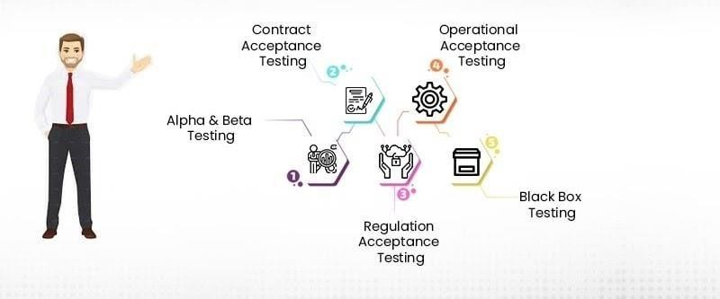

# Test cases

In the context of this thesis it is important to note the use of subtle differences in the definition of automated testing. In literature we often find mentions of how automated test cases can require a lot of manual effort coding cases.

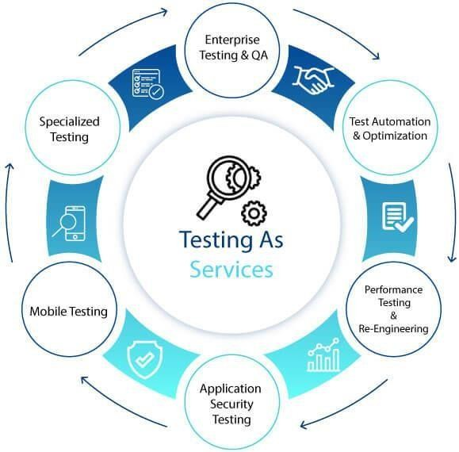

# Automated Acceptance Testing

Automated acceptance testing (AAT) is the practice of executing business logic test cases automatically and can serve as an addition to user acceptance testing . Some sources also discuss the automation of user acceptance testing, in which case the automated acceptance tests are UAT tests as described above. It mostly revolves around the idea that businesses which procure software define a set of rigorous requirements with clearly defined input and output data. When this is the case, test cases can be automated using a variety of tools making use of UI selectors or visual user interface automation . This means that scripts could be written to automate user acceptance test cases with the intent to reduce the manual effort emerging from the repeated execution of acceptance testing.

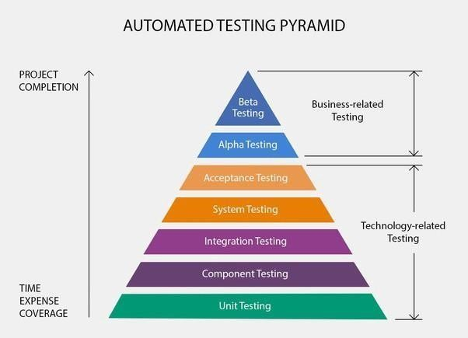

# Conclusions

It seems evident that large software customers should aim to have their UAT be tightly integrated into the software product development process in order to improve the quality of software which they can procure. For this to work companies must improve their own knowledge management and change management strategies and adapt them specifically to user acceptance testing.